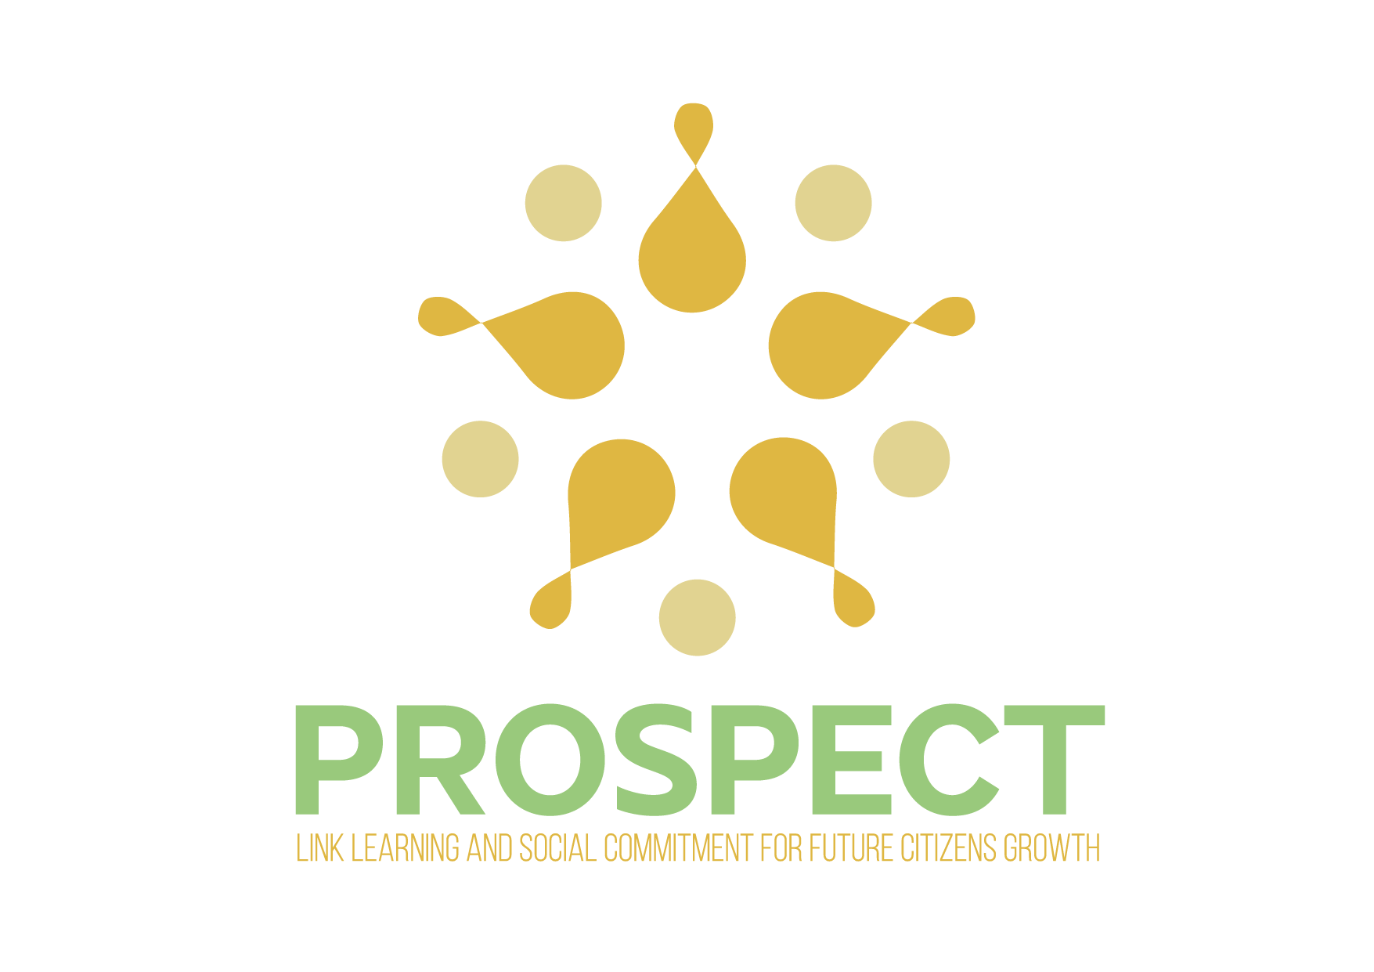

PROSPECT
2019-1-FR01-KA201-063174

IO3 – EDUCATIONAL MODEL

O3: EDUCATIONAL MODEL

AUTHOR: TUCEP – ICPG4

Project information
Project title: | PROSPECT: Link learning and social commitment for future citizens growth
Agreement number: | 2019-1-FR01-KA201-063174
Project’s partners: | AFORMAC (Applicant, France); Institut za Podgotovka na Slujiteliv Mejdunarodni Organizacii Zdruzhenie (Bulgaria); Regional Department of Education – Pernik (Bulgaria); Wyzsza Szkola Biznesu i Nauk o Zdrowiu (Poland); Asociacion Cultural Euroaccion Murcia (Spain); AEVA - Associação para a Educação e Valorização da Região de Aveiro (Portugal); Direzione Didattica Secondo Circolo Pg (Italy); Tiber Umbria Comett Education Programme (Italy); Direzione Didattica III Circolo Perugia (Italy).

With the support of the Erasmus+ Programme of the European Union.

Disclaimer:
The European Commission’s support to produce this publication does not constitute endorsement of the contents which reflects the views only of the authors, and the Commission cannot be held responsible for any use which may be made of the information contained therein.

Table of contents
1. PROSPECT Project 4
2. Aims of PROSPECT model 6
3. PROSPECT educational model based on Service-Learning methodology 8
3.1 Why to include the Service Learning in the school curriculum 11
3.2 How to design a learning unit based on the Service-Learning (SL) 13
3.3 The PROSPECT Learning Unit based on Service-Learning 16
4. How to use the PROSPECT model 21
5. Curricular activities based on Service-Learning 22
6. Results from the learning experiences tested at national level 23

PROSPECT Project

The PROSPECT project aimed at developing and testing an education model addressed to all school levels, starting from kindergarten to secondary junior school, focused on Service Learning, as a crucial moment for passing from knowledge (know) to skill (know how to be) and competence (know how to do). This process guarantees the training of citizens’ ability to act with critical thinking and to face the new challenge of the global society.
The main objectives are:
- Creation of learning experiences based on the Service-Learning methodology aimed at developing curricular and interdisciplinary competences including the global citizenship ones;
- Improvement students’ global citizenship competences through a set of activities that allow them to gain knowledge and skills to actively engage in and try to solve a real problem in the community;
- Involvement of school teachers and trainers in a training path aimed at sharing competences and practices with reference to a new educational model based on the Service Learning methodology;
- Development of a global educational model incorporating Service Learning in school curricula at all educational levels.
The project activities, developed with reference to all compulsory education levels, aim to develop a proposal for the creation of a global education model that includes debate and Service Learning in school programs through experimental learning units.
The main activities for the achievement of the project objectives are the following:
- Collection and analysis of interesting practices in six European countries about the strengthening of global citizenship skills in curricular activities, for the monitoring of their impact on pupils’ competences.
- Design of an educational model incorporating global citizenship skills, Service-Learning methodology and debate in the curricula for formal education.
- Implementation of peer learning experiences addressed to teachers and trainers for designing curricular activities based on Service Learning as the set of activities which allow students to acquire global citizenship skills.
- Testing the educational model based on Service-Learning methodology in all education levels covered by the project partners.
The project has started in September 2019 and ends in February 2022.

The Partnership
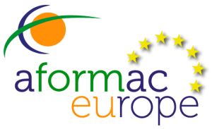 | AFORMAC (Applicant, France)  Address: 37 Boulevard Aristide Briand – Clermont-Ferrand  Email: m.schaefer@aformac.fr  Website: https://www.aformac.fr/
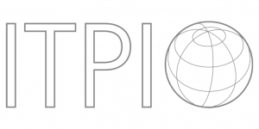 | ITPIO - Institut za Podgotovka na Slujiteliv Mejdunarodni Organizacii Zdruzhenie (Bulgaria)  Address:  Email: http://itpio.eu/  Website: http://itpio.eu/
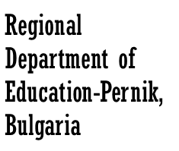 | Regional Department of Education – Pernik (Bulgaria)  Address:  Email: mstefanova_riopk@abv.bg  Website: http://ruobg.com/selectrio/
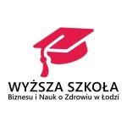 | Wyzsza Szkola Biznesu i Nauk o Zdrowiu (Poland)  Address: ul. Piotrkowska 278, 90-361, Łódź  Email: a.orska@wsbinoz.pl  Website: https://www.medyk.edu.pl/
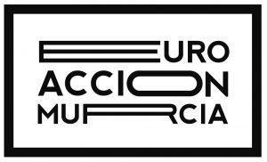 | Asociacion Cultural Euroaccion Murcia (Spain)  Address: C/Mariano Ruiz Funes, 18 Murcia  Email: sarapereira.euroaccion@gmail.com  Website: http://www.euroaccion.com/
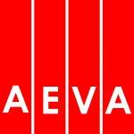 | AEVA - Associação para a Educação e Valorização da Região de Aveiro (Portugal)  Address: Rua Francisco Fereira Neves, 567 - Aveiro  Email: andreia.baptista@citizens.pt  Website: https://www.aeva.eu/
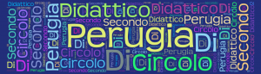 | Direzione Didattica Secondo Circolo Pg (Italy)  Address: Via M. Magnini, 11 - Perugia  Email: pgee00200l@istruzione.it  Website: https://secondocircolopg.edu.it/
TUCEP - Tiber Umbria Comett Education Programme (Italy)
Address: Via Maritiri 28 marzo, 35 - Perugia
Email: tucep@tucep.org
Website: http://www.tucep.org/
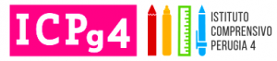 | Direzione Didattica III Circolo Perugia (Italy)  Address: Via P. Da Palestrina - Perugia  Email: pgic868005@istruzione.it  Website: http://www.istitutocomprensivoperugia4.it/

Aims of PROSPECT model

The PROSPECT educational model represents a prototype which defines a new learning model for all school levels, starting from the kindergarten to the secondary junior schools, based on the Service-Learning methodology, affecting the crucial moment for passing from knowledge (know) to skill (know how to be) and competence (know how to do).
The main objective of this educational model is to develop the students’ global citizenship competences assuring the training of a citizen’s ability to act with critical thinking and to face the new challenge of the global society.
The implementation of a new educational model including the Service Learning in all school programs, will create learning experiences based on a holistic approach, aimed at developing curricula and interdisciplinary competences according to the approach of Global Citizenship Education (GCED).
It is one of the strategic areas of UNESCO’s Education Sector programme for the period 2014-2021 and follows the Education 2030 Agenda and Framework for Action, notably Target 4.7 of the Sustainable Development Goals (SDG 4 on Education), which invites all countries to “ensure that all learners are provided with the knowledge and skills to promote sustainable development, including, among others, through education for sustainable development and sustainable lifestyles, human rights, gender equality, promotion of a culture of peace and non-violence, global citizenship and appreciation of cultural diversity and of culture’s contribution to sustainable development”.
Global Citizenship Education prioritizes the relevance and content of education in order to build a peaceful and sustainable world. Both European documents also emphasize the necessity to foster the knowledge, skills, values, attitudes and behaviours that allow individuals to take informed decisions and assume active roles locally, nationally and globally.

The PROSPECT Educational Model include mainly 3 parts:
- Curricular learning units based on the Service Learning as a set of activities that allow students to gain knowledge and skills in order to become citizens able to act with critical thinking and to face the new challenge of the global society.
- Collection of Open Educational Resources available on Moodle platform where training and didactics tools, as well as the outcomes of the national model implementation, will be consultable by teachers, trainers, students and other stakeholders.
- The results from the national testing of the curricular learning activities implemented in the partner countries schools, pointing out the advantages of Service Learning in curricular activities in order to develop students’ global citizenship competences.

The educational model is basically addressed to school teachers and trainers, students and policy makers.
Supported by this Educational Model, teachers and trainers have the opportunity to test curricular activities based on Service Learning that allow students to gain knowledge and skills to actively engage in and try to solve a real problem in the community.
In other words, the school, more and more committed to the values of active citizenship education, can find an interesting pedagogical and didactic reference in the Service-Learning proposal, capable of using the best didactic indications suggested to teachers today, orienting them towards the development of the pro-social dimension and active citizenship.
On the other hand, Service Learning is an additional opportunity for students, a significant added value to their normal learning experience, which is not limited to the classroom.
Students have the opportunity to play an active role, as protagonists, in all phases of the project, from its conception to its evaluation up to the carrying out of solidarity activities related to a need existing in the community, through a participatory commitment to the development of possible and meaningful solutions.
Through the Service Learning, students have the opportunity to “move” within their regular school curriculum by testing their knowledge and skills in a real environment and at the service of the community, dealing with authentic problems, developing skills and growing a sense of identity and belonging to their local environment.
Finally, this document has a strategic nature, addressing political authorities in charge of school education and training in the school system at regional and national level for systematizing the Service-Learning methodology for improving students’ global citizenship skills and competences as well as key competences.

PROSPECT educational model based on Service-Learning methodology

Service Learning is an extensive pedagogical proposal on a global scale and there are various definitions in the literature. María Nieves Tapia, founder and director of the Centro Latinoamericano de Aprendizaje y Servicio Solidario, defines Service Learning as "a set of solidarity service projects or programs (intended to meet in a delimited and effective way a real and felt need in an area, working with and not only for the community), with a protagonist participation of students, starting from the initial planning phase until the final evaluation and linked in an intentional way with learning content (including curricular content, reflections, development of skills for citizenship and work)"
The pedagogical origins of Service Learning can be discovered in John Dewey and Paulo Freire. Freire (1970) believed education was a process of empowerment. Rather than conceiving education as a 'banking' process which views students as empty accounts waiting to be filled, Freire regarded the teacher-learner relationship as a reciprocal relationship. Teachers teach but are also learners; learners learn but also teach. Ideally, service-learning is a process of empowerment for students, faculty and community members alike as together they are co-learners and co-teachers in creating better communities. Like Freire, Dewey rejected the notion that education was an accumulation of knowledge and, instead, argued that education was more about developing student judgment, a skill necessary for participatory democracy.
In view of all above, it can state that Service Learning (SL) is an educational approach that involves students as protagonists of a service to the community: a "pedagogical revolution" that, starting from a real need related to students, the community or a particular event, develops curricular learning and social skills through the search for solutions in a reciprocal dialogue between classroom and reality.
It is therefore a process of human and cognitive growth that is summarized in the motto "Learning serves, serving teaches"; subjects interact and collaborate to solve problems through learning on a cognitive, affective and cultural level in a circular dimension of solidarity in which students, through an educational negotiation, become protagonists of their learning and social change.
The added value is given by the fact that, while it promotes cognitive development, it also encourages the development of the person’s dimensions that could be forgotten: the social, ethical and spiritual dimensions. Service-Learning, by confronting students with problems present in the real life, brings them closer to their community, making them responsible for the social needs of the community.
From an educational point of view, Service-Learning is a method that is fully consistent with current educational guidelines, which are demanding that schools work to develop students' skills, rather than being an environment dedicated only to the transmission of knowledge.
Competence-based teaching requires that students are confronted with real problems and are made responsible for tackling them as protagonists, using all the cognitive, affective, cultural and relational resources at their disposal.
Thanks to this approach, students are not only brought into contact with reality and learn about real problems, but they are encouraged to make their own personal contribution to their solution.
Although the variety of experiences, which reflect different cultural contexts, there are three elements that characterise Service-Learning:
- Solidarity activities must be related to a need existing in the community and with the members of the community in which they intervene. It is not, in short, a welfare practice.
- Students have an active role, as protagonists, in all phases of the project, from its creation to its evaluation.
- Solidarity action must be fully integrated into the school curriculum and allow for better learning.
Service Learning practice

Identification of a need existing in the community tackled WITH community members
Protagonism of students and teachers in all phases of the project
Solidarity action integrated into the school curriculum

If we wanted to summarise the different features of Service-Learning, we could say that it is an approach:
- Research-oriented: experiences arise from the detection of problems and the implemented project is addressed to their solution;
- Curricular: the activities are integrated and linked to the contents of the school curriculum;
- Competency-focused: students test their knowledge and skills, and develop their competence by measuring themselves against authentic problems;
- Interdisciplinary: the problems are generally characterized by complexity and, for their solution, it is necessary to use more subjects, which interact and integrate with each other;
- Collaborative: the design and implementation of Service-Learning projects involves the whole class group, which becomes a learning community.
- Participatory: this is not a welfare practice, but a collaboration with the recipients of the project, who are involved on an equal level. They do not simply receive help, but are themselves a resource for student’s growth;
- Empowering: Service-Learning allows meaningful experiences of active citizenship where the school is involved with a social responsibility;
- Transformative: social responsibility means a commitment to both personal and social improvement as it is something that improves the reality of community life.
In order to guarantee the achievement of long-term results through the implementation of the methodology based on Service-Learning, it is necessary to support the development of a network of relationships, internal and external to the school, so that the external community also participates actively, including through the establishment of networks and alliances in the area and with the subjects that contribute to the implementation of the activities.
Finally, the projects should be systematised at school level, because the Service-Learning approach is not achieved by planning additional activities to the school curriculum, but by implementing structured activities that continue over time (beyond the end of the project and beyond the end of the school year) .

Why to include the Service Learning in the school curriculum
This educational approach allows to broaden the social intelligence of the student protagonists, widening the horizons of cultural, intercultural and global literacy by making them acquire global citizenship skills. For this reason, it is extremely effective for the design and implementation of inclusive learning projects for schools of all educational levels.
In this way, the learning projects addressed to the achievement of social skills will not become additional paths to those already included in the curricular programs, but the extension of the social dimension that highlights the importance and dignity of human being, claiming the rights, needs and values.
Service-Learning, therefore, points the school's educational planning towards the planning of learning paths ("Learning") in real-life contexts in which students can develop skills (disciplinary, transversal, professional, pro-social behaviours) through the implementation of an intervention ("Service") for the community the school is located on. All activities are carried out within the school's educational offerings, are an integral part of the curriculum and contribute to the overall education of the individual.
Several researches have pointed out that Service-Learning activities are aimed at raising levels of competence and participation in school activities, motivation to study, improvement of self-esteem and encouraging the acquisition of pro-social behaviours.
The objective of these initiatives is to create learning paths that can convey the importance of responsibility and commitment to the community and the common good: students who participate in these experiences grow in terms of the development of their sense of humanity, as they personally experience the values of solidarity, inclusion, civic engagement. Similarly, the same students learn more easily and achieve better results than their peers who have not participated in activities based on Service-Learning.
We can say that the Service-Learning, in addition to facilitating the acquisition of competence provided by the school curriculum, facilitates the achievement of the following objectives:
- increasing the sense of responsibility, social competence and self-esteem;
- improvement of relationship with others and with members of other ethnicities;
- enhancing ability to accept cultural diversity;
- having greater trust in adults;
- being able to work with the disabled and elderly people;
- strengthening the empathy ability and willingness to help others;
- to encourage engagement and involvement of local volunteer organizations;
- improvement of skills in reading and writing, art, maths;
- increasing class participation and motivation in study;
- reducing the risk of school dropout;
- stimulating a more positive school climate;
- increasing mutual respect among teachers and students.

How to design a learning unit based on the Service-Learning (SL)
The design of a learning unit based on SL begins with a careful analysis of the needs existing on the territory and community the school is located in, in order to verify the possibility of launching intervention strategies that combine the specific school learning objectives with active service to the local community.
It is very important that the SL action is linked to a real need emerging from the territorial context where the school is located in, and that the action has an interdisciplinary connection. Furthermore, the models of activities proposed in the learning unit should have the characteristic of replicability so that they can be implemented in areas and circumstances different from the first experimentation.
For a successful planning of the activity, it is important that the objectives to be achieved are well defined, in relation both to the skills that students are asked to acquire and to the socio-relational objectives.
The involvement of students in every phase of project implementation remains a central element, since the sharing of objectives promotes a sense of responsibility for the achievement of the expected results and stimulates significant learning processes in young people.
Finally, it is essential that the learning unit constantly emphasizes the centrality of the curriculum in order to stress the structural connotation of educational methodology of the SL action. The more the project is connected to the curricular learning objectives, the more students participate in a conscious and active way: therefore, the activities planned with SL methodology should not be promoted as sporadic and extracurricular learning opportunities, but as structured didactic actions, defining the educational experience as a path that involves transversally the subjects, acting at the same time on the acquisition of transversal and pro-social competences (soft skills).
Considering the above assumptions, the design of a learning unit based on the Service-Learning methodology is usually set up in 5 phases, as shown in the following table:

Phase | Description | Action/outcome
- Motivation | Sharing the project objectives among the involved actors.  Sharing the educational value of the proposal and involvement of students.  Raising students’ awareness on their active role in each phase of the project. | Protocols, network agreements.  Meetings with stakeholders.  Awareness meetings with students.
- Diagnosis | The involved class investigates the theme/existing need and identifies the available resources (economic, human, etc.) for the implementation of the project. | Summary document at the school board or class council level.
- Design and planning | The school, together with the community, plans and designs specific actions based on a careful assessment of risks, limitations, opportunities and strategies. | Learning project that will answer to the following questions:  What to do? What is the purpose? What are the learning and service goals? Together with whom? Where? Who does what? What is learned (content)? When (time)? How much (cost)?
- Implementation | The school implements the planned actions with the collaboration of the target community. | Implementation of the planned actions: development of the learning and service contents.
- Closing and assessment | The school reflects on the lessons learned, the actions quality and the impact to the community.  Sharing the achieved results with the target community. | Evaluation tools: self-assessment questionnaire, evaluation grid, etc..

All the learning unit phases are affected by the following three transversal processes which allow the achievement of the expected results:
Process | Description | Action/outcome
Reflection | Critical reflection on the actions:  - Formal activity implemented by the teacher based on the learning and service objectives;  - Informal reflection coming out spontaneously from students. | Brainstorming, circle times, clinical interview, meetings, seminars.
Documentation and communication | Materials systematization aimed at maintaining and communicating all the project developments to the involved actors. | Written documents, videos, audios, pictures, interviews, presentations, social posts, etc…
Monitoring and Evaluation | Actions planned in all project phases aimed at analysing the strengths and weaknesses in order to improve the ongoing project. | Questionnaires, interviews, logbook, etc…

Motivation
Diagnosis
Design and planning
Implementation
Closing and assessment
REFLECTION
DOCUMENTATION AND COMMUNICATION
MONITORING AND EVALUATION

The PROSPECT Learning Unit based on Service-Learning
Taking into consideration the basic structure described in the previous section, the PROSPECT partnership develops a set of 22 learning units covering the following four macro concepts:
- ENVIRONMENTAL SUSTAINABILITY
- IMMIGRATION
- GENDER EQUALITY
- GLOBAL CITIZENSHIP
The selected topics are consistent to the main objective of the PROSPECT Educational Model to support and promote the development of global citizenship skills in students, by strengthening and putting into practice the UNESCO recommendations (2015) and the Agenda 2030 for Sustainability Development.
Each learning unit including in this educational model foresees four phases:

IDENTIFICATION
PLANNING
IMPLEMENTATION
EVALUATION AND DISSEMINATION
REFLECTION
DOCUMENTATION AND COMMUNICATION
MONITORING AND EVALUATION

The first step “Identification” represents the basis for the development of the learning unit where the relevant elements will be identified, as shown in the following table:
- IDENTIFICATION
TITLE | Providing the learning unit title
SCHOOL LEVEL | Select the school level the learning unit can be implemented in:  - kindergarten  - primary school  - junior secondary school  - secondary school  - vocational educational training  - other (please, specify)…………………………………
CONTEXT | Short description of the environment where the learning activities will be developed (number of students, age of students, involved teachers, etc…).
NEED/PROBLEM TO BE TACKLED | Description of the need/problem existing in the community, detected by the teachers or students that the activities will be based on.  Identify the advantages the activities can provide to the community and how these can be linked to the teaching planning.
TARGET GROUP INVOLVED | Specify the target groups who will be involved in the activity (key players, stakeholders, beneficiaries).
METHODOLOGIES | Describe the methodology adopted during the activity implementation (e.g. brainstorming, discussion, individual and group analysis, etc…).  The methodologies should be innovative.

After identifying the main learning project elements, the school shares the objectives among the involved actors, as well as the educational value of the proposal. Teachers are required to raise students’ awareness on their active role in each phase of the project in order to achieve the learning and service objectives expected by the implementation of the actions.

In the second phase “Planning”, the learning and service objectives are identified as well as the curricular subjects affected by the implementation of the actions, as specified below:

- PLANNING
MAIN OBJECTIVES  (Learning objectives) | Identification of learning objectives which must be linked to the subjects involved in the learning path with particular reference to knowledge, skills and objectives for the development of skills.  They are outlined in clear and specific terms in order to subsequently evaluate the results.
GLOBAL LEARNING OBJECTIVES  (Service objectives) | The service objectives take care of the educational dimension, the development of students' personalities and their relationship with a changing society. For that reason, they are considered Global Learning objectives.  Specify the GL objectives that will be achieved through the implementation of the activity taking inspiration from the following topics included in the UNESCO document:  - Local, national and global systems and structures  - Issues affecting interaction and connectedness of communities at local, national and global levels  - Underlying assumptions and power dynamics  - Different levels of identity  - Different communities people belong to and how these are connected  - Difference and respect for diversity  - Actions that can be taken individually and collectively  - Ethically responsible behaviour  - Getting engaged and taking action  For more information concerning the global learning objectives, you can download the UNESCO document here: Global Citizenship Education  unesdoc.unesco.org/in/rest/annotationSVC/DownloadWatermarkedAttachment/attach_import_59f36c73-b9c9-4898-aea4-f93623d8a898?_=232993eng.pdf?to=71&from=1
KEY COMPETENCES FOR LIFELONG LEARNING | Select the key competences covered by the learning unit:  - Literacy  - Multilingualism  - Numerical, scientific and engineering skills  - Digital and technology-based competences  - Interpersonal skills and the ability to adopt new competences  - Active citizenship  - Entrepreneurship  - Cultural awareness and expression
EU CITIZENSHIP EDUCATION COMPETENCES | Select the EU Citizenship competences covered by the learning unit:  - Communication in mother tongue/foreign languages  - Social and civic competences  - Cultural awareness and expression  - Sense of initiative and entrepreneurship  - Mathematical competence and basic competences in science and technology  - Digital competence  - Learning to learn
SUBJECTS INVOLVED | Specify the curricular subjects involved in carrying out the activity (integrated or connected)

The PROSPECT educational model focuses specifically on promoting the development of students' global citizenship competences through the methodology of Service-Learning. For that reason, the partnership paid particular attention to the selection of global learning objectives among those provided by the UNESCO document.

The third phase “Implementation” represents the central core of the Service-Learning: it describes the phases that will lead teachers and students in the design and implementation of the Service-Learning project on the basis of the context analysis carried out through the administration of a questionnaire among the addressed community actors. For that reason, the specific activities to be carried out within the community cannot be defined at this stage. All the details related to the activities, results and resources engaged can be added at the end of the implementation process and will be different depending on the need/problem detected by the students.
The information to be included in this phase is summarized in the following table:
- IMPLEMENTATION
DESCRIPTION OF THE ACTIVITIES | Description of the phases that will bring to the Service-Learning project by defining and providing the following information:  - What teacher will do  - What pupils will do  - Which the activities’ results will be  - When the actions will be done  - How the community will be involved  What the teacher does What the pupil does  Listing the activities Listing the activities
RESOURCES | Identify the resources needed to carry out the activity:  - Human resources (skills, internal and external experts, etc.)  - Financial resources (possible funding sources for purchase of supplies, materials, services, etc.)  - Possible partnerships with community actors
SETTING OF THE ACTIVITIES | Providing information about the activities to be carried out inside and outside the classroom.

The fourth phase is the “evaluation and dissemination”: based on the main objectives and learning global objectives, a set of elements to be evaluated by the teachers at the end of the activities should be listed, as well as the tools they want to use. The educational model basically provides two evaluation tools:
- Self-assessment questionnaire aimed at promoting deep understanding of content topics and learning styles, as well as letting students consider their decisions, reflect on actions and plan future processes. It also encourages students to take more responsibility for learning during the implementation of the Service-Learning project.
- Evaluation grid aimed at assessing the achievement of students global learning objectives on the basis of the Topics and Learning Objectives established by the UNESCO Global Citizenship Education document.
As far as the dissemination is concerned, this phase makes it possible to plan the promotional activities to be carried out at the end of the Service-Learning project in order to share the results with the community and any other stakeholders. Also, the dissemination tools can be indicated at this stage.
Depending on the actual need/problem detected by students and the Service-Learning project implemented, it will be possible to integrate the dissemination activities and tools.

- EVALUATION AND DISSEMINATION
EVALUATION ELEMENTS | List the learning activity elements you want to assess.
EVALUATION TOOLS | List the evaluation tools you want to use, e.g. self-assessment questionnaire, evaluation grid, SWOT analysis, etc. (include the template of evaluation tool).
DISSEMINATION ACTIVITIES | Describe the dissemination actions to be undertaken in order to communicate and spread the learning activity carried out through the Service-Learning methodology.
DISSEMINATION TOOLS | Describe the tools for disseminating the learning activity carried out (e.g. events, brochures, social media posts, etc…)

How to use the PROSPECT model

In order to achieve the main project objectives, the PROSPECT Educational Model has been designed on the basis of the following requirements:
- learning approach designed on different students’ age group;
- teaching/learning methodologies with reference to the different educational level;
- global citizenships competences to be acquired;
- expected results from the implementation of activities based on Service-Learning methodology aimed at allowing students to gain knowledge and skills for solving a real problem in the community;
- tools for developing approaches and methodologies;
- demonstration prototype related to the learning model implementation.
In the next section, 22 learning units are illustrated, with reference to specific pupils’ age groups, school levels and competences/skills to be developed. All these practices can be easily tested by teachers and trainers who have at their disposal in each activity sheet, information about activity's area, methodologies, age group, duration, aims and objectives, materials and resources to be used and indications for preparing, implementing and evaluating each activity.
According to the project schedule, the partnership should implement the piloting of learning units included in this Handbook by involving 100 pupils and 20 school teachers/trainers at all educational levels (kindergarten, primary, secondary junior and high schools) for each participating country. The piloting will allow students to be the protagonists in identifying the need or problem in the community their school is located in, but especially in implementing activities to solve the observed problem encouraging the growth of critical citizens actively involved in the future of society.
The methodologies and contents of the present Educational Model will be revised based on the feedback collected by the national stakeholder committee carried out in each country and addressed to school teachers/trainers and experts involved in educational field that will analyse its rationale, purpose, competences and open educational resources (Handbook Version 02).
Piloting results will be then reported and shared among partners and will be collected in a final transnational report about the model implementation for letting students acquire global citizenship skills. Report will contain the main quantitative and qualitative data and results of the piloting activities together with the main suggestions for the implementation of global education models incorporating the Service-Learning methodology in school curricular activities. The collected data will be summarised in the policy guidelines elaborated by the partnership at the end of the project.

Curricular activities based on Service-Learning
In the annexed section, the learning units based on Service-Learning methodology are included and available to the school teachers to be tested during their curricular activities. The following table summarises the area, title, school level and students’ age per each learning unit:
AREA | TITLE | SCHOOL LEVEL | STUDENTS’ AGE
ENVIRONMENTAL SUSTAINABILITY | - Do not cut that tree! | Kindergarten | 5 years old
 | - Green garden for a healthy life | Primary school | 8-9 years old
 | - What do you eat? | Junior secondary school | 12-15 years old
 | - Water: a precious resource! | Primary school | 7-8 years old
 | - Climate chaos | Secondary school | 15-16 years old
IMMIGRATION | - Let’s all hold hands! | Kindergarten | 4-5 years old
 | - We are all world citizens | Kindergarten | 5 years old
 | - One world, different nation  One school, different culture | Primary school | 7-8 years old
 | - Cinderella without borders | Primary school | 9-10 years old
 | - A world without walls | Junior secondary school | 12-14 years old
 | - Together | Secondary school | 14-16 years old
GENDER EQUALITY | - Let’s play...but is it a girl’s or a boy’s game? | Kindergarten | 4-5 years old
 | - Two-faced Janus: a gender problem | Primary school | 8-9 years old
 | - Breaking hammers and brooms | Primary school | 10 years old
 | - We are equal! | Junior secondary school | 10-12 years old
 | - A gender issue | Junior secondary school | 12-14 years old
 | - What is your role in the play of the life? | Secondary school – Vocational Education Training | 16-20 years old
GLOBAL CITIZENSHIP | - You and me... children with the same rights! | Kindergarten  Primary school | 5-7 years old
 | - The friendship | Primary school | 8-9 years old
 | - Digital Global Citizenship | Primary school  Junior secondary school | 9-12 years old
 | - The human rights | Junior secondary school | 11-14 years old
 | - We as citizens of world | Secondary school | 16-19 years old

Results from the learning experiences tested at national level

https://en.unesco.org/themes/education2030-sdg4
Tapia Marìa Nieves, Educazione e solidarietà. La pedagogia dell’apprendimento-servizio (2006) Rome, Città Nuova Editrice.
https://digitalcommons.unomaha.edu/cgi/viewcontent.cgi?article=1152&context=slceslgen
Freire, P. (2002). Pedagogia degli oppressi. Torino: EGEA
Fiorin Italo, Otre l’aula. La pedagogia del Service, Mondadori, Milano, 2016. Fiorin I, Insegnare ad apprendere, La Scuola, Brescia, 2014 Fiorin Italo, La buona scuola, La Scuola, Brescia, 2008(2016)
Furco and Billig, 2002; Gregorova, Heinzova and Chovancova, 2016
Reworked by María Nieves Tapia, Educazione e Solidarietà. La pedagogia dell’apprendimento- servizio, Città Nuova, Roma, 2006; Italo Fiorin (a cura di), Oltre l’aula. La proposta pedagogica del Service Learning, Mondadori Università, Milano, 2016.
Reworked by María Nieves Tapia, Educazione e Solidarietà. La pedagogia dell’apprendimento- servizio, Città Nuova, Roma, 2006; Italo Fiorin (a cura di), Oltre l’aula. La proposta pedagogica del Service Learning, Mondadori Università, Milano, 2016.
Thanks to the support provided by CVM Comunità Volontari per il Mondo, Ancona (Italy)

